**EXPERIMENT 4**

**SOLUTION OF SYSTEM OF EQUATIONS**

**1.Gauss Elimination Method**

**CODE**

clc

clear all

a=input("coefficient of equation: ");

b=input("constants: ");

% a=[2,3,1;1,2,3;3,1,2];

% b=[9;6;8];

ab=[a b];

n1=size(ab);

n=n1(1);

n2=n1(2);

x=zeros(n,1);

for k=1:n

for i=k+1:n

m=ab(i,k)/ab(k,k);

for j=k:n2

ab(i,j)=ab(i,j)-(m*ab(k,j));

end

end

end

disp(ab);

for i=n:-1:1

sum=0;

for j=i+1:n

if (j<=3)

sum =sum +ab(i,j)*x(j);

end

end

x(i)=(ab(i,n2)-sum)/ab(i,i);

end

fprintf('\n solution is:');

disp(x);

**OUTPUT**

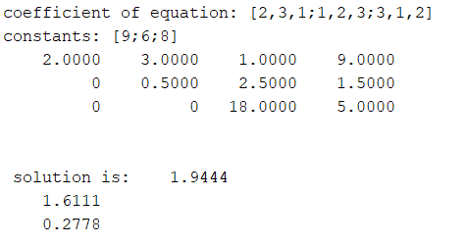

**2.Gauss Jordan Elimination Method**

**CODE**

clc

clear all

a=input("coefficient of equation: ");

b=input("constants: ");

% a=[2,3,1;1,2,3;3,1,2];

% b=[9;6;8];

ab=[a b];

n1=size(ab);

n=n1(1);

n2=n1(2);

for k=1:n

for i=k+1:n

m=ab(i,k)/ab(k,k);

for j=k:n2

ab(i,j)=ab(i,j)-(m*ab(k,j));

end

end

end

for k=n:-1:1

for i=1:k-1

m=ab(i,k)/ab(k,k);

for j=1:n2

ab(i,j)=ab(i,j)-(m*ab(k,j));

end

end

end

disp(ab);

for i=n:-1:1

sum=0;

for j=i+1:n

sum =sum +ab(i,j)*x(j);

end

x(i)=(ab(i,n2)-sum)/ab(i,i);

end

fprintf('\n solution is:');

disp(x);

**OUTPUT**

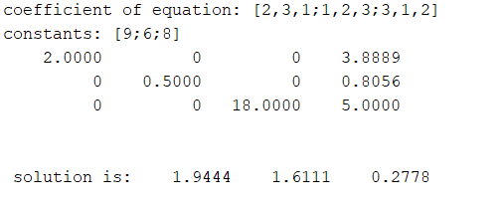

**3.LU Decomposition**

**CODE**

clc

clear all

a=input("enter the first matrix: ");

b=input("enter the second matrix: ");

c=[a b]

[m ,n]=size(c)

l=a

for i=m-1:-1:1

for j=1:1:i

l(j,:)=l(j,:)-l(i+1,:)*(l(j,i+1)/l(i+1,i+1));

end

end

l

for i=1:m

l(i,:)=l(i,:)/l(i,i);

end

l

o=l(2,1);

l(2,1)=l(3,2);

l(3,2)=o;

l

u=a

for i=2:1:m

for j=m:-1:i

u(j,:)=u(j,:)-u(i-1,:)*(u(j,i-1)/u(i-1,i-1));

end

end

u

y(1)=c(1,n);

for i=2:m

s=0;

for j=1:i-1

s=s+l(i,j)*y(j);

end

y(i)=(c(i,n)-s)/l(i,i);

end

y

x(m)=y(m)/u(m,m);

for i=m-1:-1:1

s=0;

for j=i+1:1:m

s=s+u(i,j)*x(j);

end

x(i)=(y(i)-s)/u(i,i);

end

for i=1:m

fprintf('x(%d)=%f\n',i,x(i));

end

**OUTPUT**

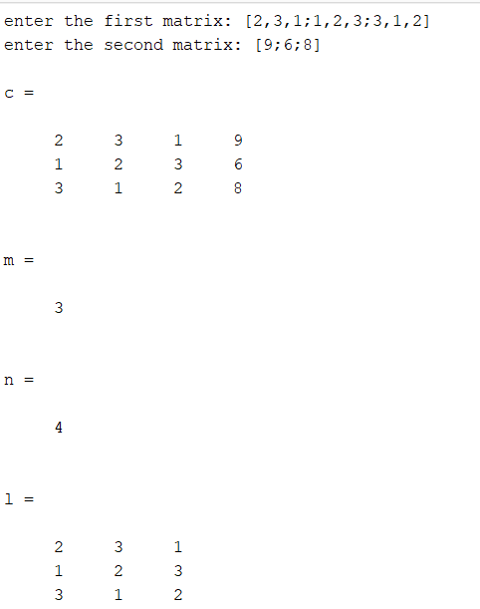

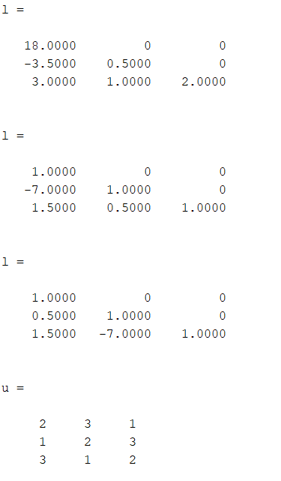

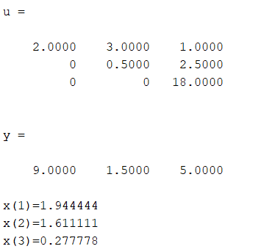

clc

clear all

a=input("enter the first matrix: ");

b=input("enter the second matrix: ");

[L U]=lu(a);

L

U

Y=inv(L)*b

X=inv(U)*Y

Using direct formula!